# CIREN/TransPAC2 (SCI-0441096) Quarterly Report1-3011-

**1-October-2009 thru 31-December-2009**

# James G. Williams – Principal Investigator

## Summary

The CIREN/TransPAC2 project is operating within budget.

Brent Sweeny attended and presented TransPAC2 activities and updates to JET meetings during the quarter.

Brent Sweeny and John Hicks participated in support of the Supercomputing ’09 conference and exposition in Portland, Oregon in November. Hicks was a member of the measurement and monitoring team, and Sweeny a member of the routing team. A number of APAN-related projects participated in SC09. Sweeny also helped coordinate, provide, and support the extensive use of NLR for SC09 support.

Williams attended the Internet2 meeting in San Antonio, TX. He participated in various Internet2 Committee functions and chaired a meeting of the Internet2 Developing NREN South Asia Sub-group.

Jim Williams continues to participate in the Internet2 External Research Advisory Committee and the Internet2 Standing Committee on International Strategy. Williams also continues as Chair of the South Asia Special Interest Sub-Group of Internet2.

Jim Williams has an NSF award to hold a workshop in India. He will work to develop this in conjunction with Greg Cole and the NSF funded Taj Project.

Cisco TelePresence among universities and others in the research and education community continues to expand, both domestically and internationally, with Sweeny working with regional and international networks to support and coordinate these connections through the R&E telepresence exchange. This R&E telepresence exchange is the first of its type to connect with commercial Telepresence exchanges.

## Milestones and accomplishments

Hicks participated in SC09 as part of the SCinet measurement team.

Hicks received training on Inmon (<http://www.inmon.com/index.php>) and Pathveiw (<http://www.apparentnetworks.com/>). These products were using in the SC09 SCinet NOC measurement infrastructure.

All met with Greg Cole to discuss IRNC GLORIAD and TransPAC2.

Williams attended the Internet2 meeting in San Antonio, TX. . He participated in various Internet2 Committee functions (the Internet2 External Research Advisory Committee and the Internet2 Standing Committee on International Strategy) and chaired a meeting of the Internet2 Developing NREN South Asia Sub-group.

Williams will be the co-chair of the GENI Operations, Measurement, Infrastructure and Security Working group and has also agreed to be the chair of the APAN Future Internet Testbed Working Group.

Williams participated in an NSF review panel Washington, DC. This activity is always a lot of work. But, has benefits directly bearing on the TransPAC2 project including an opportunity to meet and discuss networking issue and technology with experts from around the US.

Williams met with a group of Pakistan university administrators visiting Indiana University to discus Pakistan – US research interests and activities.

GRNOC implemented a new procedure to track configuration changes on core node equipment. This process was put in to track any instances in which Engineers may have forgotten to save the changes to the configuration file while in the enable mode. Modifying and/or tracking configuration changes on core node equipment requires that the engineer modifying core node configurations save the configuration prior to exiting enable mode. 

Starting Fall 2009, the TP2-KAR-SING-0192-01517 circuit is monitored and displayed in real time on the GRNOC Atlas maps. Although the circuit was implemented in 2008 with NSF funds awarded to Jim Williams, access to monitor this service has taken time, negotiation, and coordination between participants. This circuit provides Pakistan a backhaul connection to Internet2 via TransPAC2. <http://atlas.grnoc.iu.edu/atlas.cgi?map_name=TransPAC2>.

**Operations Events and Activities**

The GlobalNOC continues to augment it facility on the Bloomington Campus. In addition, the Service Desk and Operations is preparing a disaster recovery training exercise to test services and personnel in the event of an emergency. GRNOC operations are constructing both policies and resources to ensure redundancy and resiliency for staff coping with an unexpected environmental event. In the event personnel need to transfer between GRNOC locations, full support operations should resume with minimal service interruption.

## Network Engineering

Sweeny continued to work together with partners at APAN-JP and NICT to operate TransPAC2 cooperatively, including continued investigation of improvements in areas such as how to get greater functionality out of the SONET circuits we now operate, dynamic-circuit-networking services, and closer NOC and engineering cooperation. The TransPAC2 network continues to function at the highest levels of reliability, functionality, and performance, connecting all of the R&E networks in the APAN region with their counterparts in North and South America and still provides the highest-performance path to Europe.

The single most significant network event of the year in R&E circles is the annual supercomputing conference in November, for 2009 held in Portland, Oregon. As always, TransPAC2 played a crucial role in carrying high-performance research and demonstration traffic between the APAN region and the SC09 resources, demonstrating how production high-performance networks play a vital role in the real work of scientific computing. Bandwidth-challenge winning entries also came from the APAN region, with KREOnet working with Cal Tech in the bulk-bandwidth category, and the University of Tokyo also winning. NICT and JGN2 and others also used the dynamic-circuit capability implemented for SC08 and now used fairly routinely by APAN researchers with American and European colleagues. Sweeny worked with virtually all of the APAN-region participants in the network, helping with planning for, provisioning, building, and supporting the layer2 and layer3 network connections across the WANs and the show floor, both as a lead engineer in some of those WANs—including TransPAC2—bringing the networks to SC09, and then in his SC09 SCinet routing-team capacity, coordinating the delivery of those network connections to the actual participants. Sweeny was in charge of one of the core routers for the network and worked with the team on all other aspects of the SC09 network. The SCinet network performed extremely well and everyone was quite pleased.

Pakistan connection: In the fourth quarter of 2009, Sweeny worked with network engineers at TEIN3 and PERN to help ensure continued functional operation. The PERN connection continues to operate as planned to provide relatively high-speed networking to the R&E community in Pakistan and to bring them more closely into the community of international researchers.

Sweeny is the lead engineer implementing a GlobalNOC and Cisco TelePresence R&E exchange which is rapidly interconnecting universities in the US and abroad. This ‘exchange’, much like internet exchanges which designate locations for IP carriers to meet and exchange traffic, is becoming the means of interconnecting all Telepresence-using R&E institutions worldwide. It is an NLR-funded effort with implications for all research and education networks in the world, as those networks are the means of providing connectivity among us in which we very rarely need to worry about QoS and loss, but can support this collaborative effort with our existing high-performance networks This is becoming increasingly relevant to TransPAC2 as universities in Australia and China and the Republic of Georgia have joined us in international demonstrations, and the University of Peking in Beijing, shanghai, and Shenzhen, China, will become permanently connected in January. Universities in the U.A.E and Austria have become permanently connected, and more universities in China and England are completing their connections. We have every indication that this growth will only accelerate in almost every part of the world, and as critical mass grows, so does its usefulness. Sweeny is proposing to networking groups in Asia and Europe the creation of a similar Telepresence exchanges nationally and regionally to improve support and performance, and federating them worldwide to provide high-performance, low cost-of-entry Telepresence functions in support of research and education. An interesting test of the robustness of Telepresence occurred at SC09, when we were able to conduct flawless Telepresence calls over the same networks that were concurrently carrying multiple huge bandwidth flows.

We continue to also provide technical support to Cisco as they introduce TelePresence to their international customers throughout the world. TelePresence is already a useful technology for providing immersive collaborative opportunities for university and commercial researchers internationally, but as critical mass increases among universities, and as it becomes more feasible technically and politically to interconnect islands of TelePresence users and their exchanges, its usefulness will grow and it will be necessary for R&E networks to be able to support this technology’s requirements. . So far we are the leaders in interconnecting R&E telepresence worldwide.

**TransPAC2 Dynamic Circuits Network Implementation:**

* After the flurry of activity in 2008 to successfully make the Dynamic Circuits Network capability available to the APAN R&E community for SC08, DCN continues in 2009 to be of growing interest there, and is a feature of many of the NRENs’ plans and has seen significantly greater use in 2009 and we are confident use will continue to grow as long as it is reasonably priced and as critical mass of other users and supporting applications grows.In conjunction with the greater prominence of DCN in the APAN region and its use by the Asia-Pacific research community, TransPAC2 continues discussions with APAN/JGN2 about a ‘distributed’ support and network-operations model for DCN support of this community and how best APAN and TransPAC2 efforts complement each other to provide the best support for the APAN researchers.
* In the third quarter of 2009 Internet2 transitioned DCN from a pre-production demonstration service to a production one named “Internet2 ION”, and working closely with the DCN working group. Sweeny is a member of the DCN WG.
* Researchers in the APAN region are very interested In taking advantage of the dynamic network opportunities of DCN/ION and plan to use it not only throughout the year, but especially heavily during the SC09 events in the fourth quarter of 2009, as indicated above in the section about SC09. TransPAC2 was crucial to their efforts. DCN is now regarded as a valuable asset in the TransPAC2 portfolio of services.

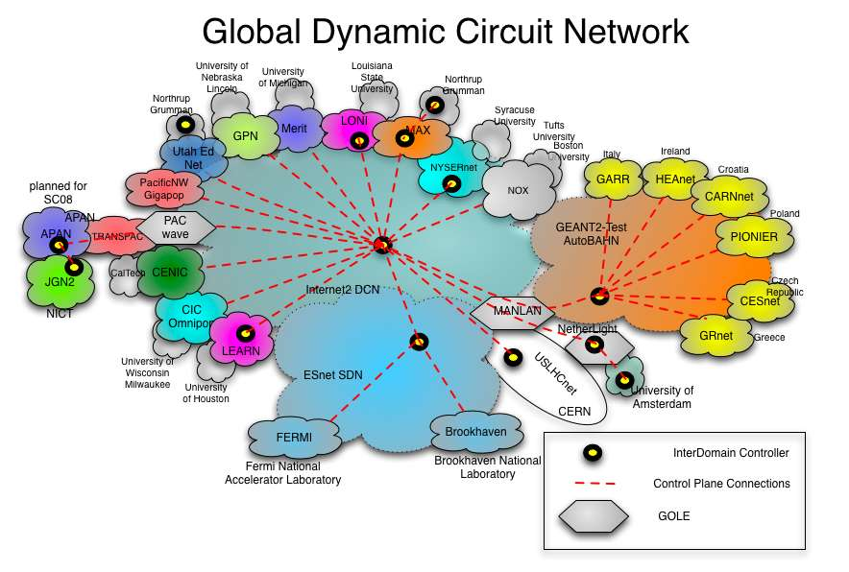

**Other engineering activities**

In addition to DCN/ION, standard services supported by TransPAC2 include IPv6 and multicast for both IPv4 and IPv6. These services continue to work without issues. We continue to investigate how to provide better ipv6 netflow instrumentation on the TransPAC2 Juniper core router(s). It appears that a new ‘advanced services PIC’ is required to provide this function for the router to generate the data; we continue to investigate whether or to what extent we can glean v6-specific data from the general flow information the router gives us now.

**IRNC related GENI activities**

Williams attended the GENI Engineering Conference in Salt Lake City. He met with the K-GENI group to plan for future project activities. He also was named co-Chair of the Operations, Measurement, Infrastructure and Security (OMIS) Working Group. This will be useful in the development of the K-GENI project and as IRNC efforts move forward to link IRNC NOCs more closely together to facilitate cross-INRC international activities.

As a side note, Williams met with DY Kim of Korea and agreed (after much persuading) to be the Chair of the APAN Future Internet Testbed Working Group, based on his activity in the GENI-OMIS WG. No good deed goes unpunished….

**South Asia Activities**

Due to a variety of factors, no proposal was submitted for the development of the Pakistan Centre for Bioinformatics and Genomics (mentioned in the previous QR). The political environment in Pakistan is difficult and there are issues within Indiana University that need to be resolved also. The proposal work has been halted at the moment. But, work can resume if the political situation in Pakistan improves.

A group of university administrators from Pakistan visited Indiana University in November. Williams met with the group for one hour to discuss existing research opportunities between the US and Pakistan (primarily those facilitated by the existing network connection such as video conferencing and database development and updating). The Pakistan Higher Education Commission has agreed to take a more active role in coordinating these research relationships.

**Measurement Activities**

* Helped organize perfSONAR workshop for the upcoming APAN 29 meeting in Sydney.
  + The workshop is organized into two one and a half hour slots.
  + Talks are scheduled from the US and AP Region.
  + http://www.apan.net/meetings/Sydney2010/schedule.php
* Met with Greg Cole to discuss IRNC Gloriad and TransPAC2 monitoring.
* Worked on perfSONAR visualization tool for NOC with GRNOC engineers.
* Worked with KDDI engineers to upgrade software in Tokyo and LA
* Worked on SC09 SCinet measurement team involvement. Details follow:

Hicks did not attend SC09 but participated as part of the Scinet measurement team. Specifically, Hicks implemented the Nagios monitoring system on all Scinet devices, helped with bandwidth challenge and other demonstrations concerning TransPAC2 and APAN. Demonstrations were conducted by NCDM & Network Design Research Center in Kyushu Institute of Technology, NTT Network Service Systems Laboratories, NICT & AIST, NICT Weather forecast, NICT Tiled Display, Osaka University, and the University of Tokyo. Hicks helped with the APAN weathermap, and received training for the inmon and pathview software monitoring systems.

TransPAC2 graph for SC09 – November 14-20

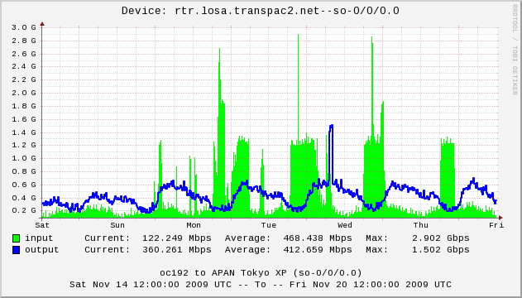

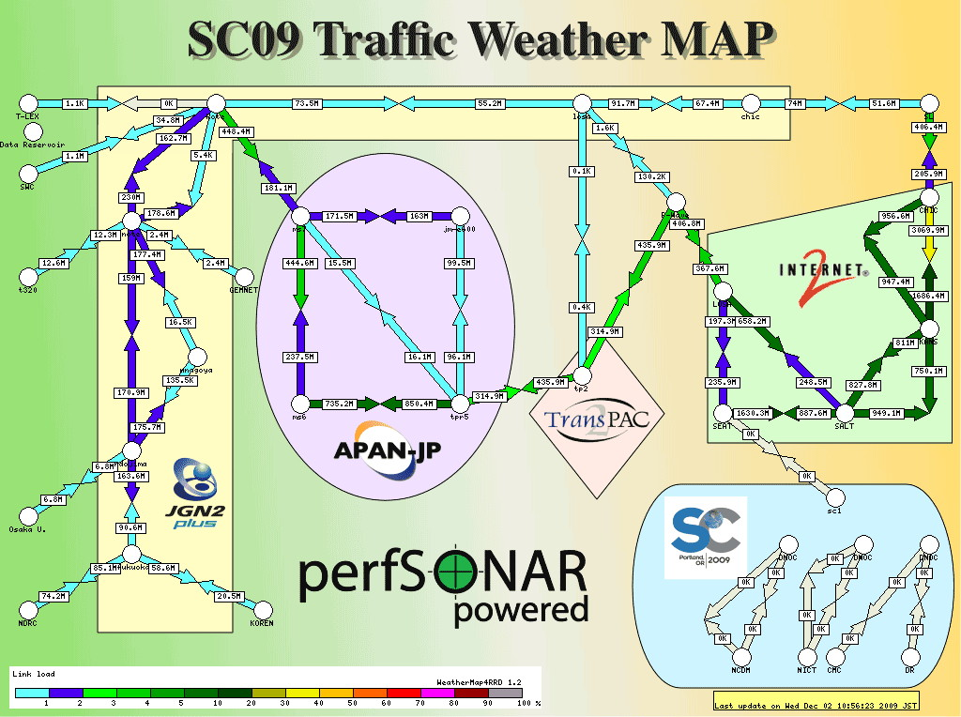

## Security events and activities

* Investigated all security incidents on the TransPAC2 network. No major incidents to report this quarter.
* Attended talk concerning course grain flow measurements for BOT and worm detection by Michael Reiter, UNC at Chapel Hill
* Discussed the security sessions at the winter 2010 APAN meeting in Sydney Australia.

***TransPAC2 Business Activity, Quarter 09/01/09 through 12/31/09***

**TROUBLE TICKET ACTIVITY** Top of Form

Bottom of Form

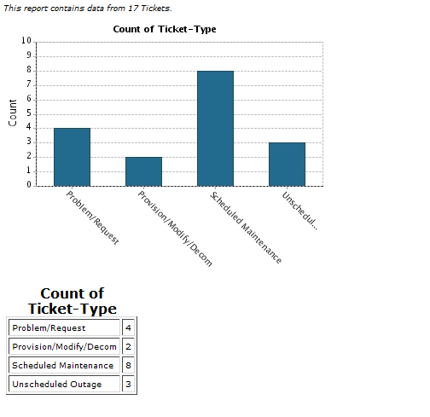

**TransPAC2 Network Operations Report**10/01/2009 - 12/31/2009

Top of Form

**New Connections**

None

**Upgrades**

None

**New Services**

None

### Unscheduled Outages Summary

|  |  |  |  |  |  |  |
| --- | --- | --- | --- | --- | --- | --- |
| **Ticket Number** | **Customer Impact** | **Network Impact** | ***Title*** | **Outage Type** | ***Start Time (UTC)*** | ***End Time (UTC)*** |
|  | | | | | | |
| [1012](http://tick.globalnoc.iu.edu/tickets/view.cgi?tick=1012&proj=62) | 1-Critical | 1-Critical | TransPAC2 Core Node T320 Available | Software | 12/08/2009 1:40 PM | 12/08/2009 1:41 PM |

### Unscheduled Outages Detail

|  |  |
| --- | --- |
| Ticket No.: | 1012:62 |
| Subject: | TransPAC2 Core Node T320 Available |
| Affected: | Core Node T320 |
| Start Time: | Tuesday, December 8, 2009, 1:40 PM (1340) UTC |
| End Time: | Tuesday, December 8, 2009, 1:41 PM (1341) UTC |
| Description: | TransPAC2 core node T320 was briefly unavailable to the community. TransPCA2 Engineers are currently working with equipment provider Juniper Networks to determine the cause of the outage. |
|  |  |

### Scheduled Maintenances Summary

|  |  |  |  |  |  |  |
| --- | --- | --- | --- | --- | --- | --- |
| **Ticket Number** | **Customer Impact** | **Network Impact** | ***Title*** | **Maintenance Type** | ***Start Time (UTC)*** | ***End Time (UTC)*** |
|  | | | | | | |
| [986](http://tick.globalnoc.iu.edu/tickets/view.cgi?tick=986&proj=62) | 3-Elevated | 2-High | TransPAC2 TOKY-TransPAC2 LOSA Backbone Circuit Maintenance Completed | Circuit | 10/12/2009 3:31 PM | 10/12/2009 7:14 PM |
| [1000](http://tick.globalnoc.iu.edu/tickets/view.cgi?tick=1000&proj=62) | 3-Elevated | 2-High | TransPAC2 TOKY-TransPAC2 LOSA Backbone Circuit Maintenance Completed | Circuit | 10/13/2009 5:20 PM | 10/14/2009 3:57 AM |

### Scheduled Maintenances Detail

|  |  |
| --- | --- |
| Ticket No.: | 986:62 |
| Subject: | TransPAC2 TOKY-TransPAC2 LOSA Backbone Circuit Maintenance Completed |
| Affected: | TransPAC2 TOKY-TransPAC2 LOSA Backbone Circuit |
| Start Time: | Monday, October 12, 2009, 3:31 PM (1531) UTC |
| End Time: | Monday, October 12, 2009, 7:14 PM (1914) UTC |
| Description: | The TransPAC2 TOKY-TransPAC2 LOSA Backbone Circuit was unavailable while KDDI America rerouted cable due to road construction. Maintenance has been completed. |
|  |  |

|  |  |
| --- | --- |
| Ticket No.: | 1000:62 |
| Subject: | TransPAC2 TOKY-TransPAC2 LOSA Backbone Circuit Maintenance Completed |
| Affected: | TransPAC2 TOKY-TransPAC2 LOSA Backbone Circuit |
| Start Time: | Tuesday, October 13, 2009, 5:20 PM (1720) UTC |
| End Time: | Wednesday, October 14, 2009, 3:57 AM (0357) UTC |
| Description: | The TransPAC2 TOKY-TransPAC2 LOSA Backbone circuit was unavailable while the circuit provider performed fiber work in Redondo Beach, CA. Maintenance has been completed. |
|  |  |

### Downtime and Availability

|  |  |  |  |
| --- | --- | --- | --- |
| **TransPAC2 Core Nodes** | **Down Time** | **Reporting Period Availability** | **52 Week Availability** |
| TransPAC2 T320 - LA | 0 hr 1 min | 99.99925% | 99.99981% |
| 6410 Ethernet Switch | 0 hr 0 min | 100.00000% | 99.99905% |
| 3410 Ethernet Switch | 0 hr 0 min | 100.00000% | 100.00000% |
| OOB Router | 0 hr 0 min | 100.00000% | 100.00000% |
|  |  |  |  |
| **Aggregate TransPAC2 Core Nodes** | 0 hr 1 min | 99.99981% | 99.99971% |

|  |  |  |  |
| --- | --- | --- | --- |
| **TransPAC2 Backbone Circuits** | **Down Time** | **Reporting Period Availability** | **52 Week Availability** |
| TransPAC2 LOSA-JGN2 LOSA 10GigE | 0 hr 0 min | 100.00000% | 100.00000% |
| TransPAC2 LOSA-Pacific Wave LOSA 10GigE | 0 hr 0 min | 100.00000% | 100.00000% |
| TransPAC2 TOKY-TransPAC2 LOSA | 14 hr 20 min | 99.35085% | 99.41390% |
|  |  |  |  |
| **Aggregate All TransPAC2 Backbone Circuits** | 14 hr 20 min | 99.78362% | 99.80463% |

### There are no upcoming scheduled maintenances at this time.

**Plans for 1-January-2010 thru 31-March-2010**

The focus of TransPAC2 efforts for this quarter will be to transition from TP2 to the new TransPAC3 project. This will include new circuit RFPs and a number of new services. This work will be outlined in the new TransPAC3 Quarterly Reports.

## Usage summary and performance

**Quarterly Usage Graphs**

The following graphs represent a simple breakdown of traffic behaviors on the TransPAC2 network during the fourth quarter of 2009. Also note that graphs of the Pakistan traffic have been added.

The following graph represents the aggregated traffic on the TransPAC2 network

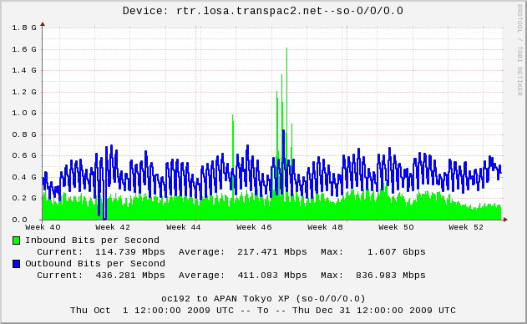

The following graph represents a list of peer contributions to the traffic load on the TransPAC2 network. Most peers are through the Internet2 network.

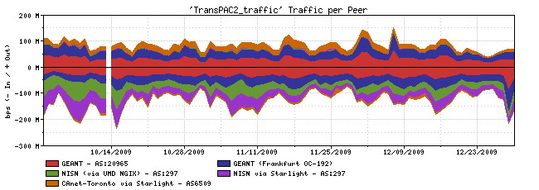

The following graph represents a simple breakdown of traffic by IP protocol.

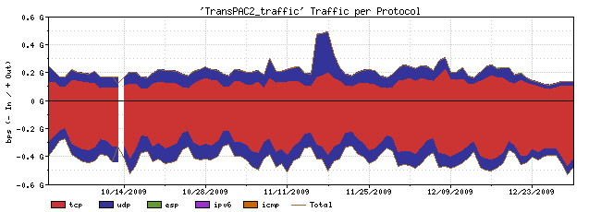

The following graph represents a list of TCP application contributions to the traffic load on the TransPAC2 network

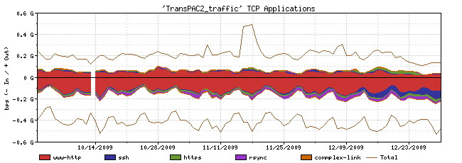

The following graph represents a list of UDP application contributions to the traffic load on the TransPAC2 network.

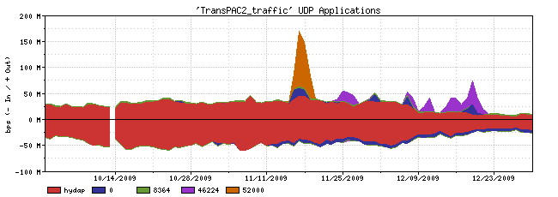

The following graph represents the distribution of traffic per ASN during the reporting period.

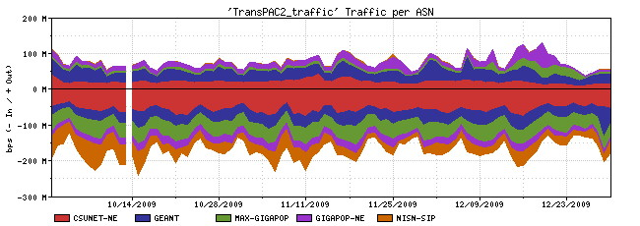

The following graphs represent information collected from the Singapore (SG) TEIN2 router concerning the SG <-> Pakistan link. Thanks to the kind assistance of our TEIN2 partners a dedicated monitoring page for SG-PK STM-1 link is now is place:

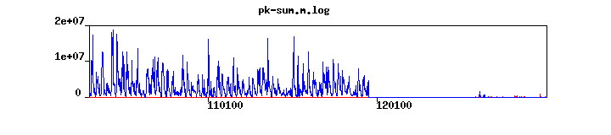

<http://noc.tein2.net:8036/cgi-bin/pk.pl> - user/passwd - tein2/tein2

This graph is a utilization verses time graph where time is increasing to the right.. We are unable to get direct access to the equipment or Netflow data but will continue to work with our TEIN2 and APAN partners to gain greater insight into the traffic the traverses this link.

The pk-sum graph represents SNMP utilization in bps. The red line is traffic inbound to the SG TEIN2 PoP. The blue line is for outbound traffic from TEIN2 SG PoP..

The sudden drop of SG-PK traffic at the end of Nov 2009 is due to the migration of this circuit from PTCL to PERN2 on PK side around 25 Nov 2009. After the migration, it took about a month for PERN2 to solve the router PIC problem on their side during which the traffic between PERN2 and TEIN3 backbone was totally interrupted. The traffic has been restored since 24 Dec 2009. The total number of BGP prefixes currently announced from PERN2 is less than that from PTCL before the link migration. This should be the reason for the decrease of traffic level after 24 Dec 2009 in comparison with that before 25 Nov 2009.